6.100: Use the Work–Energy Theorem, 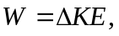 and integrate to find the work.
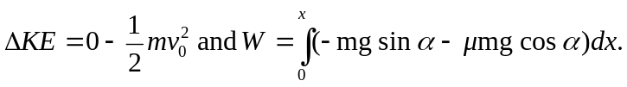

Then,
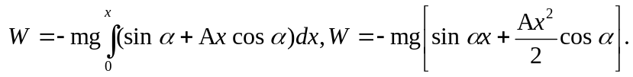

Set 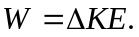
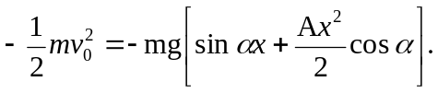

To eliminate x, note that the box comes to a rest when the force of static friction balances the component of the weight directed down the plane. So, 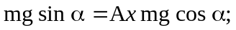 solve this for x and substitute into the previous equation.
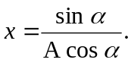
Then,

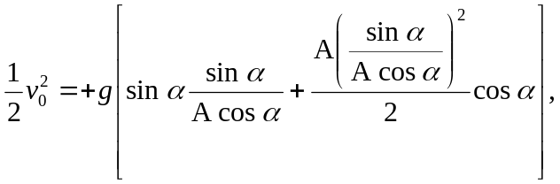

and upon canceling factors and collecting terms, 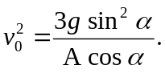 Or the box will remain stationary whenever 